Threat Assessment Procedure
- Administrator/counselor has received information on a threat made by student(s), and has written down verbatim what the student threatened.
- Have you isolated the student with adequate supervision?
- Have you confiscated any written or drawn materials and/or threat paraphernalia?
- Have you interviewed the student regarding his or her motives and state of mind?
- Have you interviewed any adult who witnessed the incident or found the materials?
- Have you interviewed any other student involved or who witnessed the incident?
- Have you adequately determined between a suicidal or homicidal threat?
  - Some suicidal indicators:
    - Drawings that depict harm to oneself or are out of the context of what was assigned for the class and appears violent to self
    - Writing that has content related to self-harm
    - Talk of harm to oneself, any talk or overhearing discussion regarding harm to oneself
    - Threats of harming self/actual malicious physical harm to self
- Is suicide the primary concern? If yes, then follow your established protocol.
- Is homicide the primary concern? If yes, the follow the Virginia Model of threat determination.
  - Refer to the 11 Key Questions (page 2) to help determine threat level
- Is threat substantive? If yes, then call your Social Worker.
- If your ACES Social Worker is unavailable and you would like to speak to someone immediately, call any of the below numbers and ask to have a member of the School Based Mental Health Team return your call. Someone on the SBMH team will return your call shortly.
** If you are unsure about any step you can always call your ACES team for help.**
Relevant Phone Numbers:
Crisis Hotline Number: 888-279-8188
Child Abuse and Neglect Hotline: 800-392-3738
Cindy Naber, ACES Director: 660-254-6134
Holly Hurd, ACES Social Worker: 660-254-6136
Jody Renfro, ACES Behavior Interventionist: 660-254-3634
ACES office: 660-582-3768
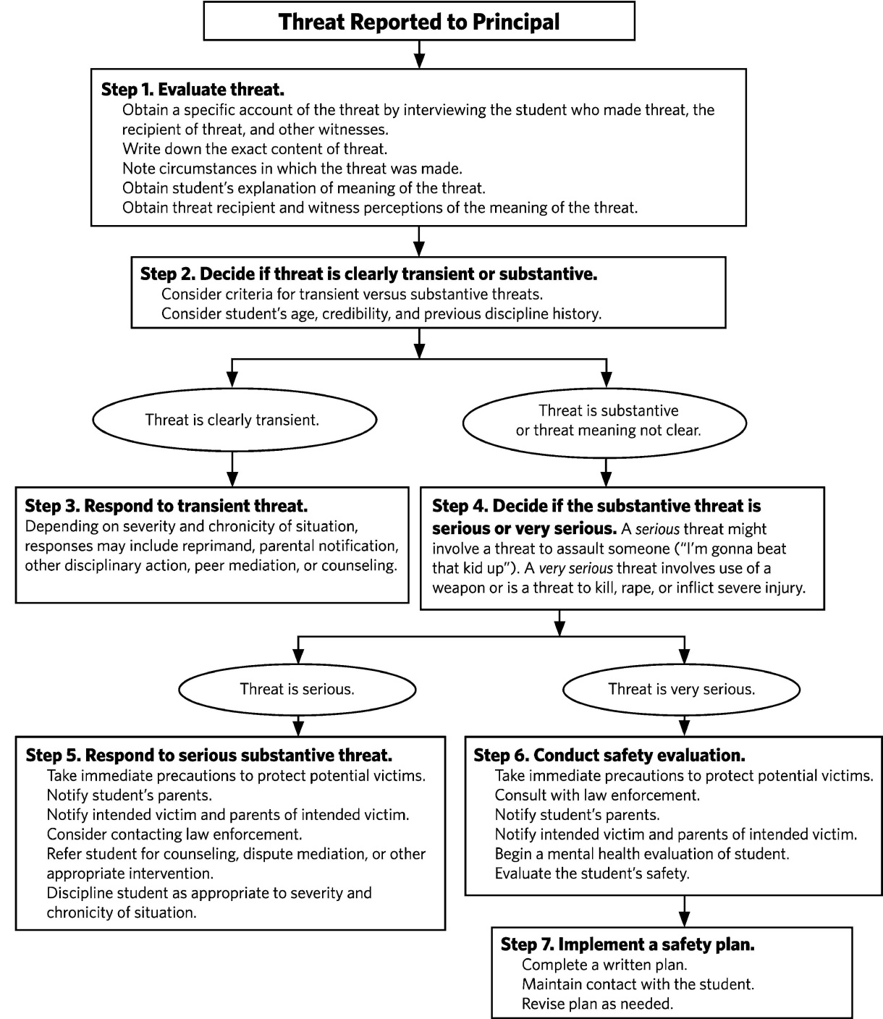
11 Key Questions to Help Evaluate Threat:

- What are the student’s motives or goals?
- Any communications of intent to attack?
- Any inappropriate interest in other attacks, weapons, or mass violence?
- Any attack-related behaviors? Making a plan, acquiring weapons, using surveillance on potential sites, etc…)
- Does student have the capacity to attack?
- Is there hopelessness or despair?
- Any trusting relationship with an adult?
- Is violence regarded as a way to solve a problem? Any peer influences?
- Are student’s words consistent with actions?
- Are others concerned about the student?
- What circumstances might trigger violence?

- Often are rhetorical remarks, not genuine expressions of intent to harm
- At worst, express temporary feelings of anger or frustration.
- Usually can be resolved on the scene or in the office.
- After resolution, the threat no longer exists.
- Usually ends with an apology or clarification.
- When in doubt, treat threats as substantive.

Transient vs. Substantive
- Express intent to physically injure someone beyond the immediate situation.
- There is at least some risk the student will carry out the threat.
- Require that you take protective action, including warning the intended victims and parents.
- May be legal violations and require law enforcement consultation.

